Chapter- 01

1. **INTRODUCTION**

Bus E-Ticket System and Detection is easy to use and anyone can understand the system. Here, in this system, you can Create, Modify and Delete the Bus E-Ticket Record of a User/customer. Also, you can view the customers/users details. This project helps us to access and manage the information easily from the database. This project will reduces the printing of Ticket for every travel or trip. The Role of Bus E-Ticket Management is to create and manage the details of customer/user and make it as QR-Code.By using Bus E-Ticket Detection ,the user/customer can scan the QR-Code and travel their journey.so the man power is reduced and MTC will gain profit and improve the Bus services and infrastructures and do benefit for peoples

This Software “Bus E-Ticket Management and Detection” is used to create and manage the information of the user/customer in day-to-day life and generate and give them a QR-Code. It stores some documents like Aadhar card, Ration card, Disability proof provided by D.R.O, Customer/user’s photo etc. The main aim of Bus E-Ticket management and Detection is to make the MTC to gain profit and serve a good service to the peoples. Because when man power and Printing tickets is reduced the MTC can control the Lost not on spending money in this.

* 1. **TECHNOLOGY USED:**

1. Python is the base language which is to be implemented in this project.

1. PyCharm Community Edition 2022.3.1 and Jupyter Notebook 6.3.0 is used for development & execution of the project.
2. MYSQL Workbench 8.0 CE is used for maintaining the database.

Chapter - 01

* 1. **NEED OF SYSTEM**
     1. **Existing System**

In the existing system,The Bus E-Ticket mamnagement system and Detection is no used instead the traditional paper based tickets are used,where the user/customer says the end destination and pay and receive from the bus conductor.which makes uncomfortable for the user/customer at some situation due lack of change to buy the ticket from the bus conductor.so it is difficult to carry change to buy ticket.

* + 1. **Proposed System**

In the proposed system,The user/customer just need to carry the QR-Code and scan in the Bus E-Ticket Detection so the customer/user no need to carry money or change to buy the ticket.This replaces the existing paper-based bus ticketing system and also prevents corruption/unaccounted money andso no need of Bus conductor so the MTC can control the loss and improve the Bus service and infrastructure and that QR-Code can be re-used.In Bus E-Ticket Management system is used to create and manage the bus e-ticket for the user/customer where the customer’s/user’s data are stored in database and it easy to use and manage.

* + 1. **Problem Statement**

It is very difficult to carry changes to buy the ticket.And also MTC faces a big problem in providing salary to the bus conductor and spending money on printing the traditional bus ticket which makes in get loss to the MTC.to overcome this kind of problem ,the Bus E-Ticket management system and Detection is used.

Chapter - 02

**2.SYSTEM REQUIREMENTS**

**2.1 Hardware Requirements**

PROCESSOR : AMD

SYSTEM TYPE : 64-Bit Operating System

ROM : 2GB

RAM : 4GB

SPEED : 2.0 GHz

CAMERA : Logictech HD Webcam C270

KEYBOARD : USB/PS2 Keyboard

MOUSE : USB/PS2 Mouse

**2.2 Software Requirements**

OPERATING SYSTEM : Windows 10

FRONT END : Python(Tkinter)(python 3.8.8 64-bit version)

BACK END : MYSQL Workbench 8.0 CE

IDE : PyCharm Community Edition 2022.3.1 and Jupyter Notebook 6.3.0

TEXT EDITOR : Notepad

Chapter - 03

**3.REQUIREMENT ANALYSIS**

**3.1 FUNCTIONAL REQUIREMENTS**

The System must provide following functionalities:

* Can Create the Bus E-Ticket for the User or customer.
* Can View the Bus E-Ticket of the User or customer.
* Can Modify/Delete the Bus E-Ticket for the User or customer.
* Storing all the data in the database.
* Can view the recent events photos.
* Can know the History,Bus-Wise fare amount and Service.
* Scan the QR-Code whether the user or customer is Authorized or Un-Authorized.

**3.2 NON-FUNCTIONAL REQUIREMENTS**

Non-Functional Requirement are:

* Secure access of the confidential data(user’s or customer’s details).
* 24 X 7 availability.
* Better component design to get better performance at peak time.

Chapter - 04

**4. SYSTEM DESIGN**

System design is the solution of a "how to approach the creation of the new system. It is composed of several steps. It facilitates the understanding and provides the procedural details necessary for implementation of the system recommended in the feasibility study. Emphasis is given on translating the performance requirements into design specification. Design goes through logical and physical stages of development. Logical design reviews the present physical system, prepares input and output specification; make editing, security and control specification; details the implementation plan, and prepares logical design walk through. The physical design maps out the details of the physical system; plans the system implementation plan and specifies hardware and software. System design translates the system requirement into the ways of the system as recommended in the feasibility study Thus, the system design is the translation from user-oriented document to a programmer or a database personal oriented document System design is a highly creative process that can be greatly facilitated by the following:

* Strong Problem Definition
* Pictorial description of the Existing System
* Set of Requirements of the new system

Chapter - 04

**4.1 Architectural diagram**

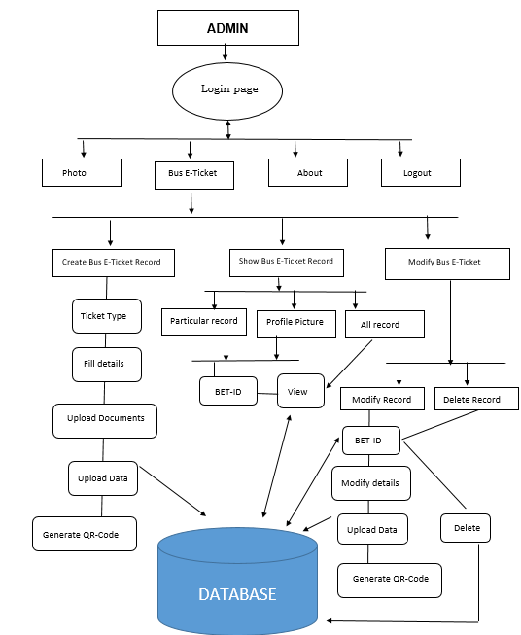

Chapter -04

**4.2 UML Diagram**

**4.2.1 Class Diagram**

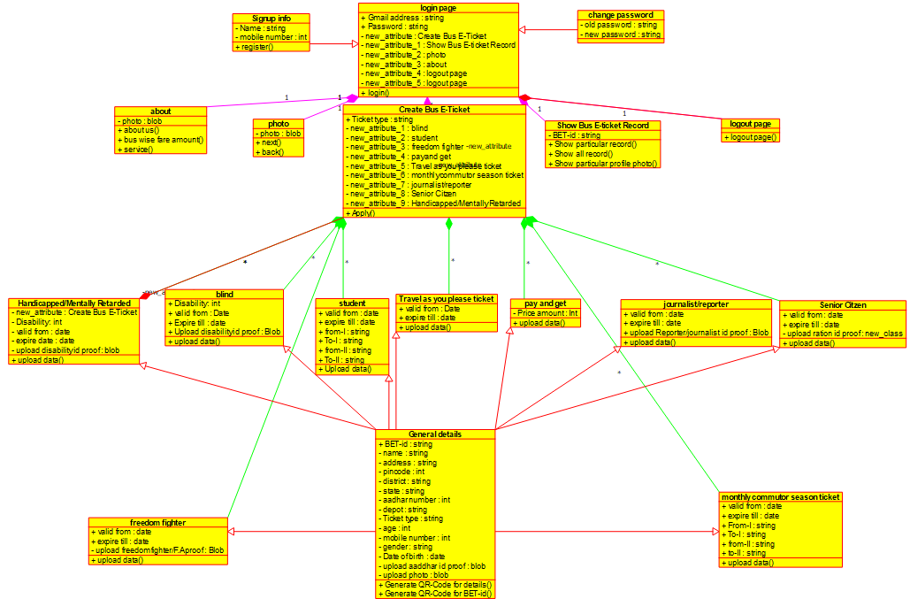

Chapter - 04

**4.2.2 Use- Case Diagram**

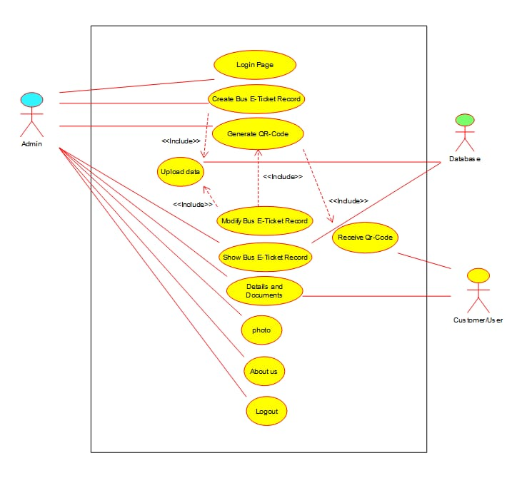

**4.2.3 Sequence Diagram** Chapter – 04

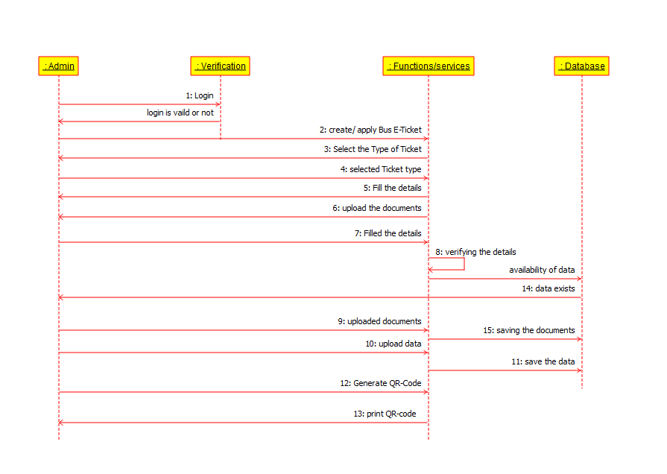

Sequence diagram for Create Bus E-Ticket Record

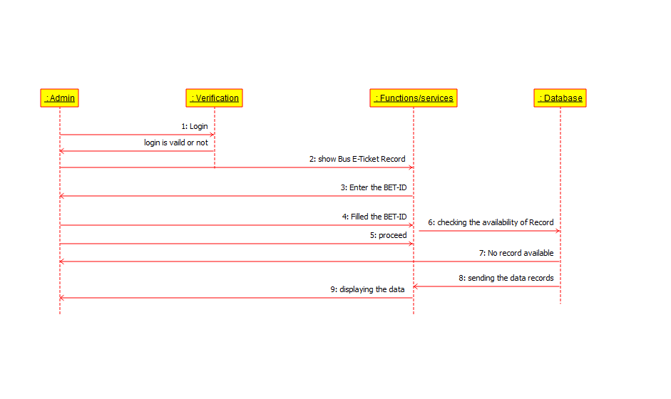

Sequence diagram for view Bus E-Ticket Record

Chapter - 04

**4.3 Database Design**

|  |  |  |
| --- | --- | --- |
| Attributes | Type |  |
| Bet_id | Varchar(20) | Primary key |
| Name | Varchar(45) | Not null |
| Address | Varchar(100) | Not null |
| Pincode | Varchar(45) | Not null |
| District | Varchar(45) | Not null |
| State | Varchar(45) | Not null |
| Aadhar_no | Varchar(13) | Not null,Unique |
| Depot | Varchar(45) | Not null |
| Ticket_type | Varchar(45) | Not null |
| Valid_from | Varchar(45) | Not null |
| Expire_till | Varchar(45) | Not null |
| Price amount | Varchar(45) | Not null |
| Mobile_no | Varchar(12) | Not null,Unique |
| College | Varchar(70) | Not null |
| From_I | Varchar(50) | Not null |
| To_I | Varchar(50) | Not null |
| From_II | Varchar(50) | Not null |
| To_II | Varchar(50) | Not null |
| Profile_pic | Blob |  |
| Age | Varchar(45) | Not null |
| Aadhar_card_pic | Blob |  |
| Gender | Varchar(45) | Not null |
| Date_of_birth | Varchar(45) | Not null |
| reporterRjournalist_pic | Blob |  |
| Disability_percentage | Varchar(45) | Not null |
| Attendant_pic | Blob |  |
| Attendant_name | Varchar(45) |  |
| Freedom_fighter_pic | Blob |  |
| Ration_card | Blob |  |

|  |  |
| --- | --- |
| Table Name | Person Details |

Chapter - 05

**5.SYSTEM IMPLEMENTATION**

**5.1 LIST OF MODULES:**

* **Login**
* **Bus E-Ticket**
* **Photo**
* **About**
* **Logout**

**5.2 MODULE DESCRIPTION:**

**Login:**

**Sign In**

* The Admin or staff can gives their respective Gmail Address and Password and logs into the system.

**Sign Up**

* The Other Staff can Register and logs into the system.

**Change Password**

* The admin or staff can change their password by entering the old password and set their new password

**Bus E-Ticket:**

**Create/Apply Bus E-Ticket**

* Selecting the Bus E-Ticket Type and Filling the Respective details,Uploading the Documents,Uploading the Data in Database and generating the QR-Code by the admin and giving to User

**Show Bus E-Ticket:**

**Show Particular Bus E-Ticket Record**

* The Admin or Staff can view the user’s Bus E-Ticket Record using their BET-ID from the database

Chapter - 05

**Show All Bus E-Ticket Record**

* The Admin or Staff can view all the user’s Bus E-Ticket Records from the database

**Show Profile picture**

* The Admin or Staff can view a particular user’s profile picture using the User’s BET-ID from the database

**Modify Bus E-Ticket:**

**Modify particular Bus E-Ticket Record**

* The Admin or staff can modify a particular Bus E-Ticket record using the User’s BET-ID and change the details and generate a new QR-Code and update the details in the database

**Delete Bus E-Ticket Record**

* The Admin or Staff can delete a Bus E-Ticket Record permanently using the User’s BET-ID from the database

**Photos**

* The admin or Staff can view the recent event photos

**About:**

**About us**

* The admin or staff can know the history of the BUS

**Bus Wise Fare Amount**

* The Admin or Staff can know the bus wise fare amount so it is easy to tell the User

**Service**

* The admin or staff can know how many service are their in city

**Logout**

* The admin or Staff can Logout their account and use another

Chapter - 06

**6. SYSTEM TESTING:**

**6.1 TESTING METHODOLOGIES**

**Unit Testing:**

A Unit corresponds to a form/class in the package. Unit testing focuses on verification of the corresponding form or class. At this level we have tested all our forms/classes individually. This testing includes testing of control paths, interfaces, local data structures, logical decisions, boundary conditions, and error handling. From this testing we were able to save, retrieve, update, delete and the search records on a table.

**Integration Testing:**

Integration testing is used to verify the combination of the software modules. In this level, we have tested by combining all unit tested forms into a subsystem. Here we found that the subsystems are performing well.

**System Testing:**

System testing is used to verify whether the developed system meets the requirements.

**Acceptance Testing:**

Acceptance is the part of the project by which the customer accepts the product. The system under consideration is tested for user acceptance by constantly keeping in touch with the system users at time of developing and making changes whenever required. We hope that after the acceptance testing the system will perform the best result for the organization. When modification will be made, we will use regression testing during the maintenance of the system. The Software System delivered to the customer may undergo changes. Changes may be due to addition of new functional modules or performance enhancement. For this purpose, proper maintenance of the system is necessary.

Chapter - 06

**Validation Testing:**

At the culmination of integration testing, software is completely assembled as a package; interfacing errors have been uncovered and corrected, and a final series of software tests-validation testing-may begin. Validation can be fined in many ways, but a simple definition is that validation succeeds when software functions in a manner that can be reasonably expected by the customer.

**Validation Test Criteria:**

Software validation is achieved through a series of black-box tests that demonstrate conformity with requirements. A test plan outlines the classes of tests to be conducted, and a test procedure defines specific test cases that will be used in an attempt to uncover errors inconformity with requirements. Both the plan and procedure are designed to ensure that all functional requirements are satisfied; all performance requirements are achieved; documentations correct and humanengineered, and other requirements are met.

Chapter - 07

**7. APPENDICES**

**7.1 SAMPLE CODING:**

**Sample code for Bus E-Ticket Management:**

from tkinter import *

import tkinter as tk

import mysql.connector

from tkinter import ttk

from tkinter import messagebox

from PIL import ImageTk, Image

from tkinter import filedialog

from sqlalchemy import create_engine

import pyqrcode

import qrcode

import io

def SIGNIN_N_SIGNUP_PAGE():

# Connect to MySQL Database

mydb = mysql.connector.connect(

host="localhost",

user="root",

password="password123",

database="buseticket"

)

# Create Table to Store User Information

mycursor = mydb.cursor()

mycursor.execute("CREATE TABLE IF NOT EXISTS login_page (id INT AUTO_INCREMENT PRIMARY KEY, username VARCHAR(255), password

Chapter - 07

mycursor.execute("CREATE TABLE IF NOT EXISTS login_page (id INT AUTO_INCREMENT PRIMARY KEY, username VARCHAR(255), password VARCHAR(255), email_id VARCHAR(255), mobile_no VARCHAR(255))")

def change_password():

def new_password():

# get inputs from user

email = email_entry1.get()

current_password = entry_current_password.get()

new_password = entry_new_password.get()

# check if current password is correct

mycursor.execute("SELECT password FROM login_page WHERE email_id = %s", (email,))

result = mycursor.fetchone()

if result is None:

messagebox.showwarning(title="Change Password->Error", message="Invalid username.")

return

……

……

root = Tk()

icon = ImageTk.PhotoImage(file='windowBusIcon.png')

root.wm_iconphoto(False, icon)

root.geometry("1470x745")

root.title("Login Page")

canvas = Canvas(root, width=800, height=800, bg="#b3ffff")

canvas.pack(fill="both", expand=True)

img = Image.open("login page.png")

resize = img.resize((600, 500))

new = ImageTk.PhotoImage(resize)

canvas.create_image(400, 120, image=new, anchor='nw')

Chapter - 07

welcome = Label(root, text="Welcome to Bus E-Ticket Management", font=('Brush Script MT', 50, 'bold'), bg="#b3ffff")

welcome.place(x=250, y=10)

login = Label(root, text="Login Info", font=('Bodoni MT Black', 30, 'bold'), fg="#0000ff", bg="#b3ffff")

login.place(x=600, y=130)

password_label = Label(root, text="Password", font=('Arial', 15, 'bold'), bg="#b3ffff")

password_label.place(x=570, y=305)

password_entry = Entry(root, show="*")

password_entry.place(x=690, y=310, width=180)

email_label = Label(root, text="Email Address", font=('Arial', 15, 'bold'), bg="#b3ffff")

email_label.place(x=550, y=255)

email_entry = Entry(root,width=60)

email_entry.place(x=690, y=260, width=180)

sign_in_button = Button(root, text="Sign In", font=('Arial', 15, 'bold'), bg='green', command=sign_in)

sign_in_button.place(x=660, y=460, width=80)

def sign_up1():

root.destroy()

signup()

sign_up_button = Button(root, text="Sign Up", font=('Arial', 15, 'bold'), bg='#ffff00', command=sign_up1)

sign_up_button.place(x=660, y=505, width=80)

def change1():

root.destroy()

change_password()

change_button = Button(root, text="Change Password ", font=('Arial', 10, 'bold'), bg='red', command=change1)

change_button.place(x=633, y=385, width=130)

root.mainloop()

SIGNIN_N_SIGNUP_PAGE

Chapter - 07

**Sample code for Bus E-Ticket Detection:**

import sys

import numpy as np

from pyzbar.pyzbar import decode

import cv2

import pygame.mixer

# Set up camera feed

video = cv2.VideoCapture(1)

video.set(3, 640)

video.set(4, 740)

while True:

# Read authorised employee list from file

with open('authorised_employee.txt', 'r') as file:

authorised_list = file.read().strip()

# print(authorised_list)

# Define sound files

pygame.mixer.init()

access_granted_sound = pygame.mixer.Sound("access_granted.wav")

denied_access_sound = pygame.mixer.Sound("denied_access.wav")

success, image = video.read()

for barcode in decode(image):

qr_text = barcode.data.decode('utf-8')

qr_text = str(qr_text)

if qr_text not in authorised_list:

color = (0, 0, 255)

# Play denied access sound

denied_access_sound.play()

display_message = "Denied Access"

Chapter - 07

else:

color = (0, 255, 0)

# Play access granted sound

access_granted_sound.play()

display_message = "Access Granted"

polygon_points = np.array([barcode.polygon], np.int32)

polygon_points = polygon_points.reshape(-1, 1, 2)

rect_points = barcode.rect

cv2.polylines(image, [polygon_points], True, color, 3)

cv2.putText(image, display_message, (rect_points[0], rect_points[1]), cv2.FONT_HERSHEY_PLAIN, 0.9, color, 2)

cv2.imshow("Video", image)

cv2.waitKey(1)

Chapter - 07

**7.2 Sample Screenshots:**

**Login page:**

**Login Info**

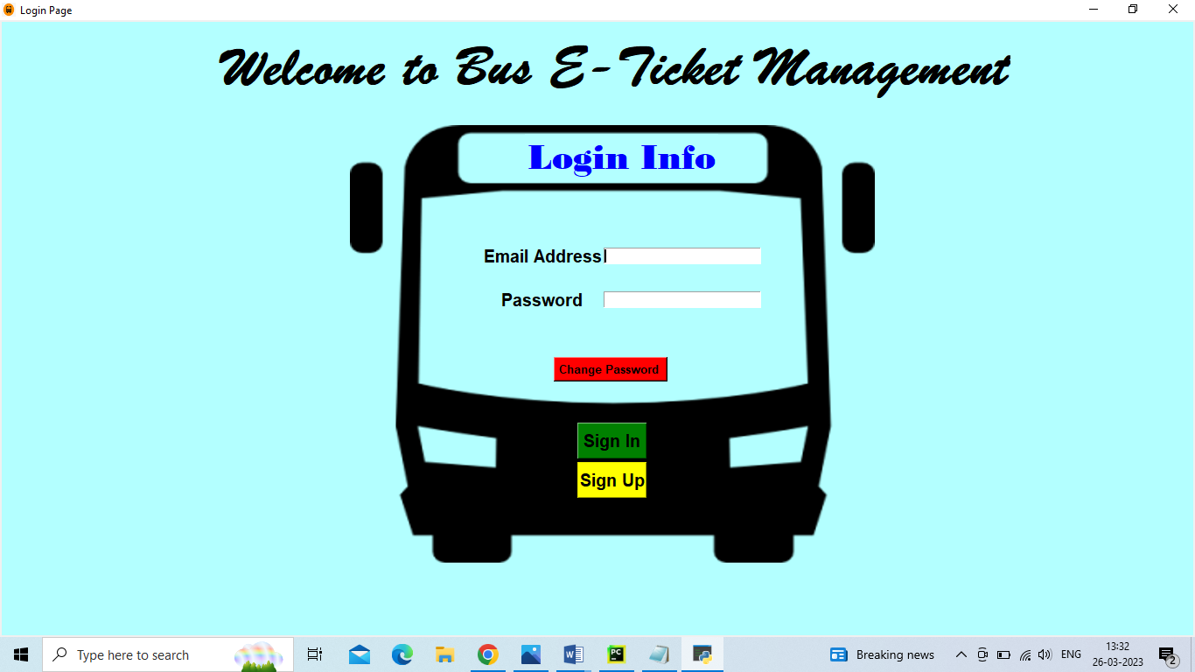

**Signup Info:**

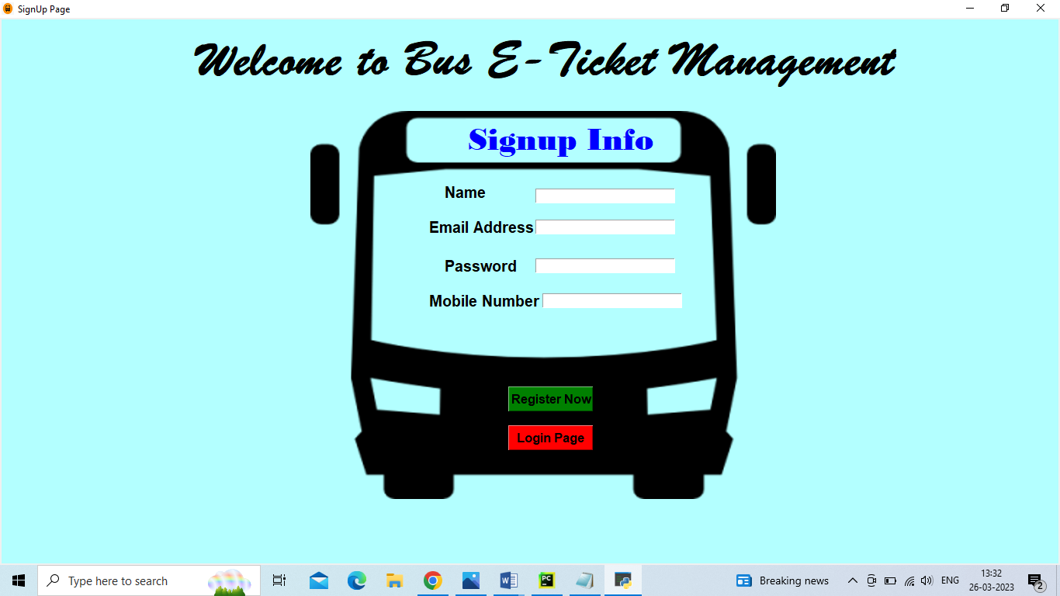

Chapter - 07

**Logged In:**

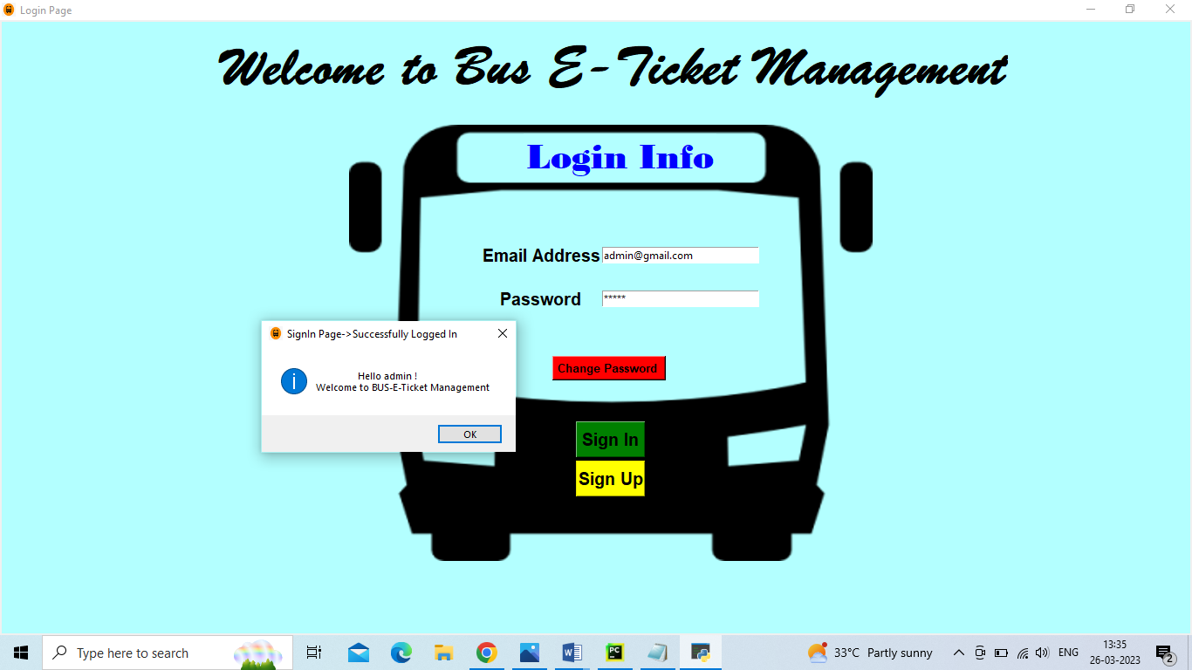

**Home page:**

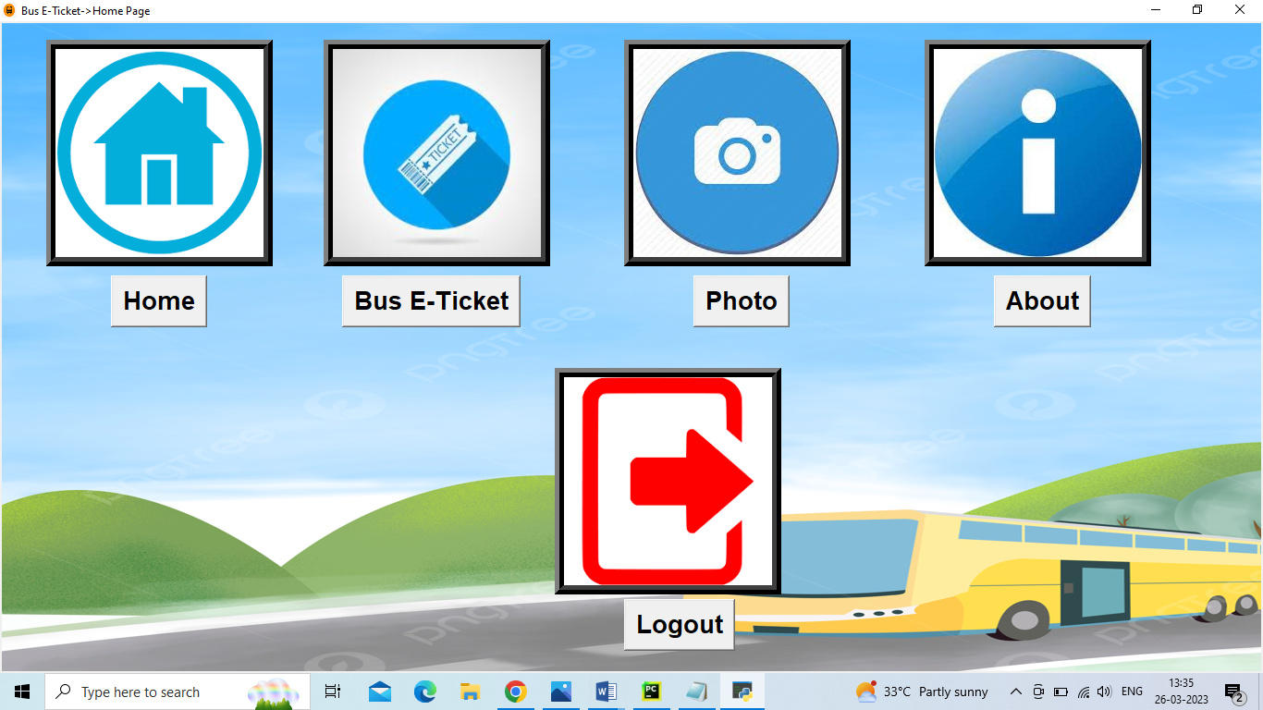

Chapter - 07

**Bus E-Ticket:**

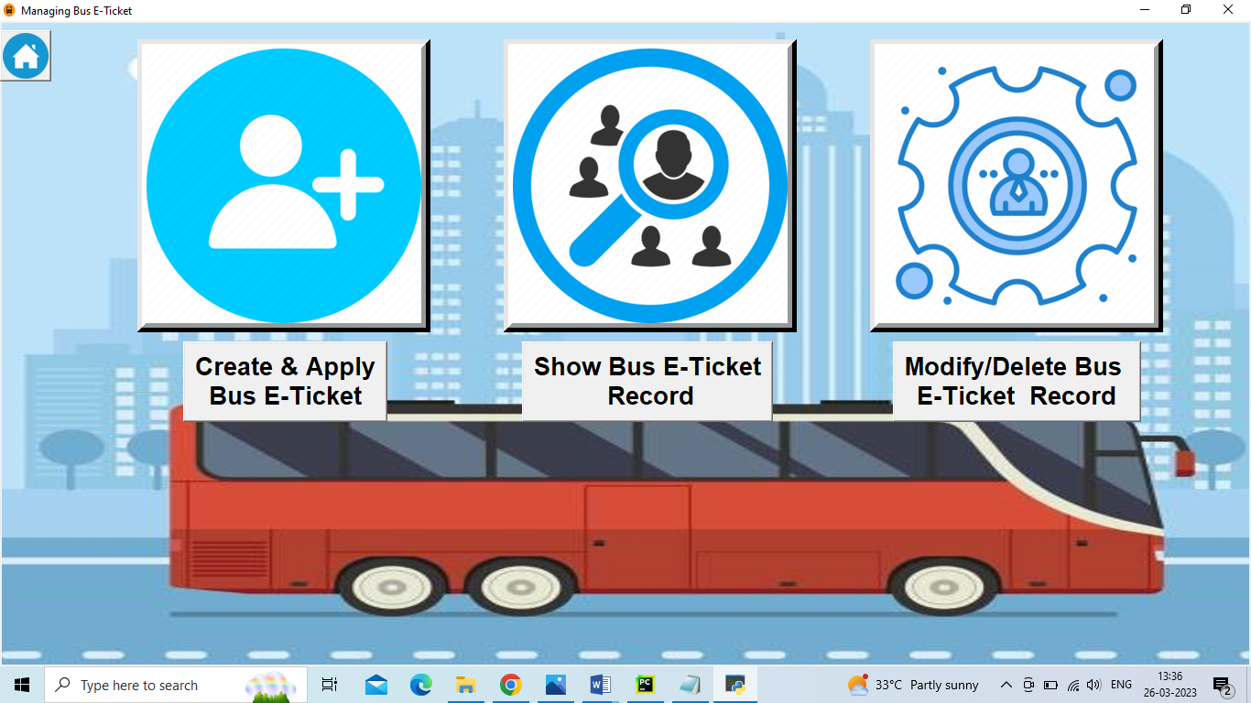

**Select your Bus E-Ticket Type:**

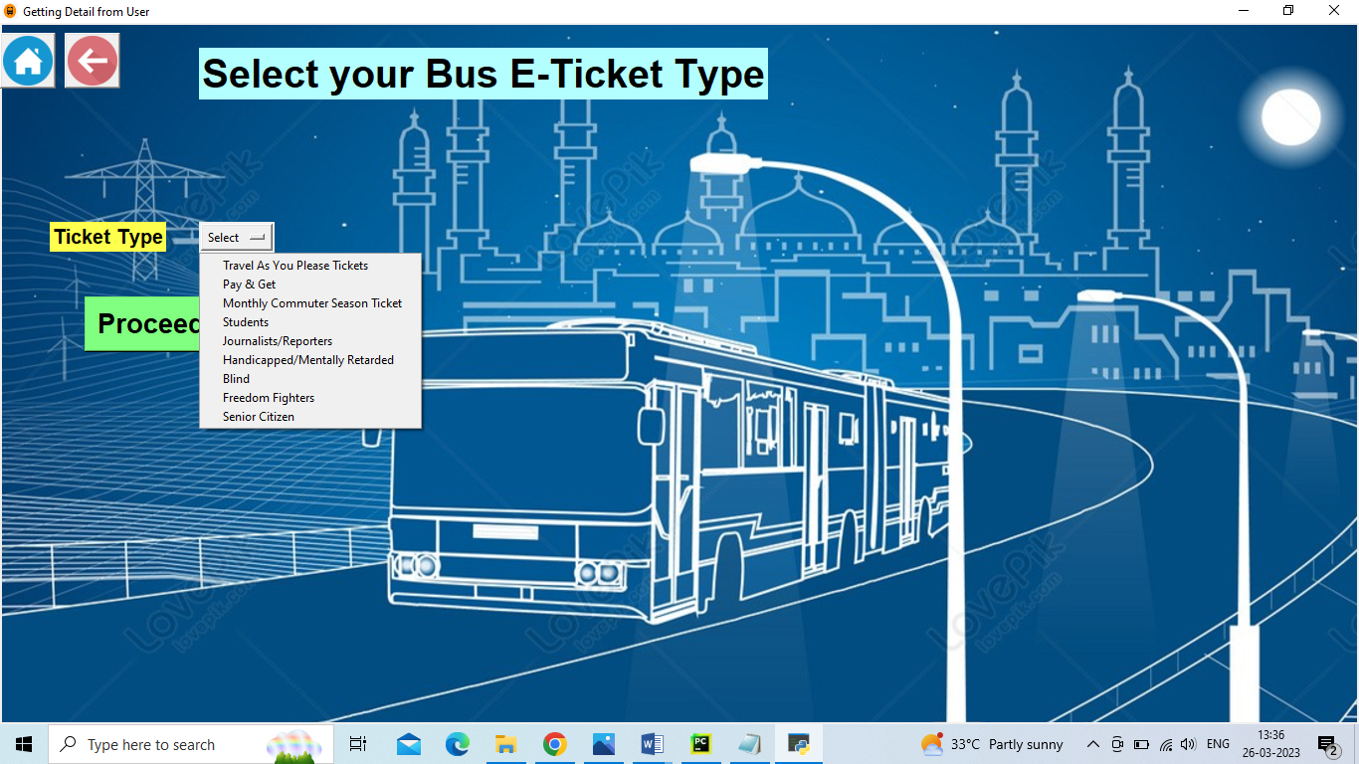

Chapter - 07

**Fill the respective details for Bus E-Ticket:**

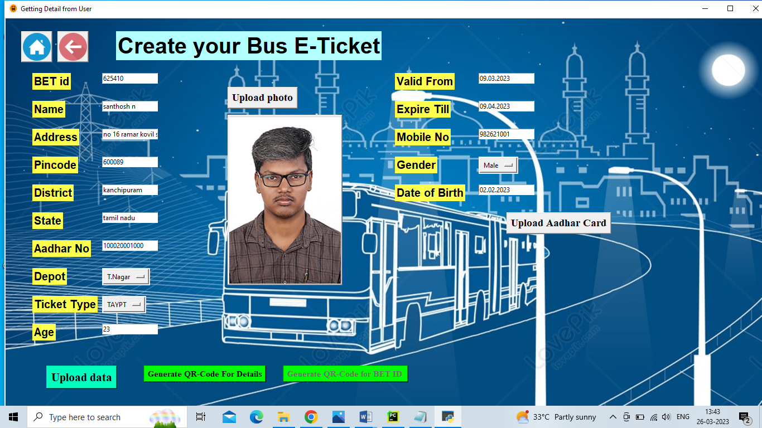

**Uploaded the Data in Database:**

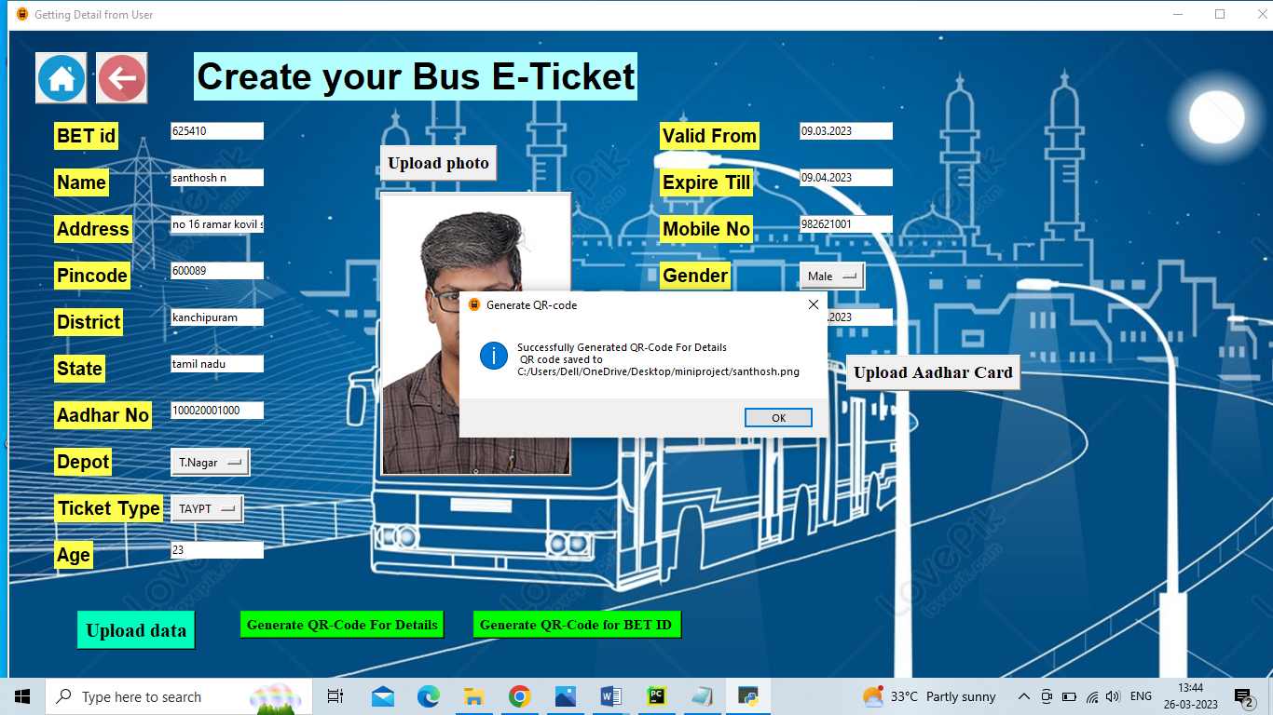

Chapter - 07

**Saving the QR-Code in System:**

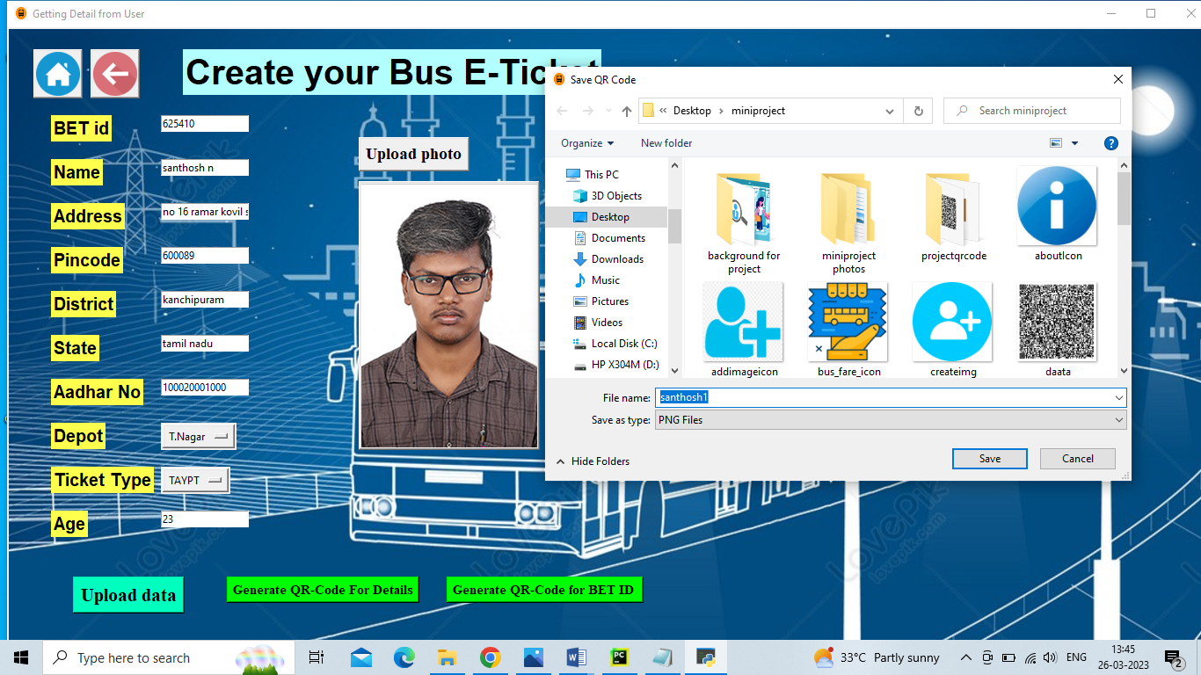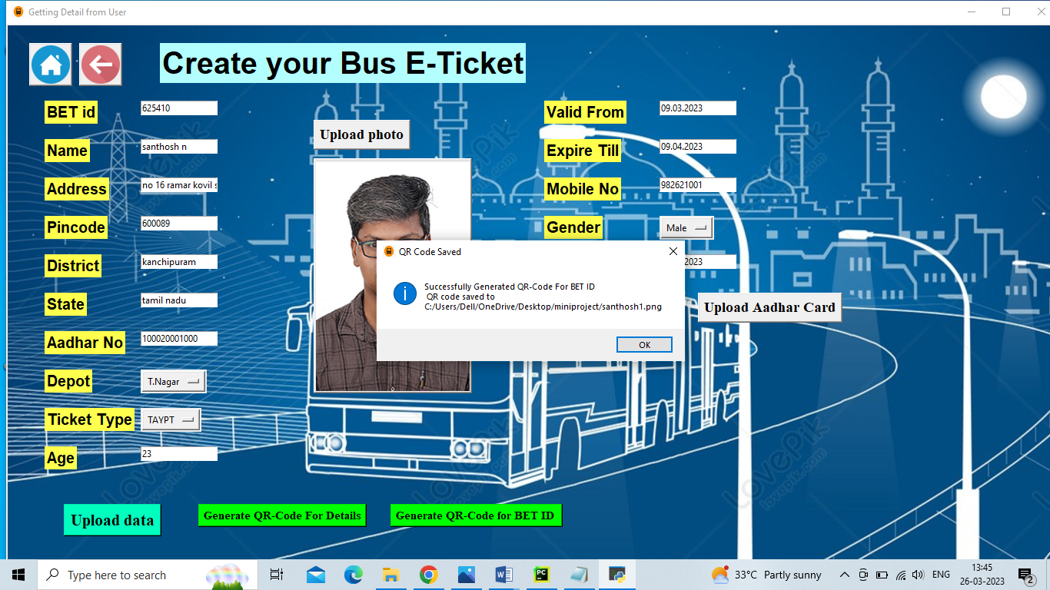

Chapter - 07

**Show Bus E-Ticket Record:**

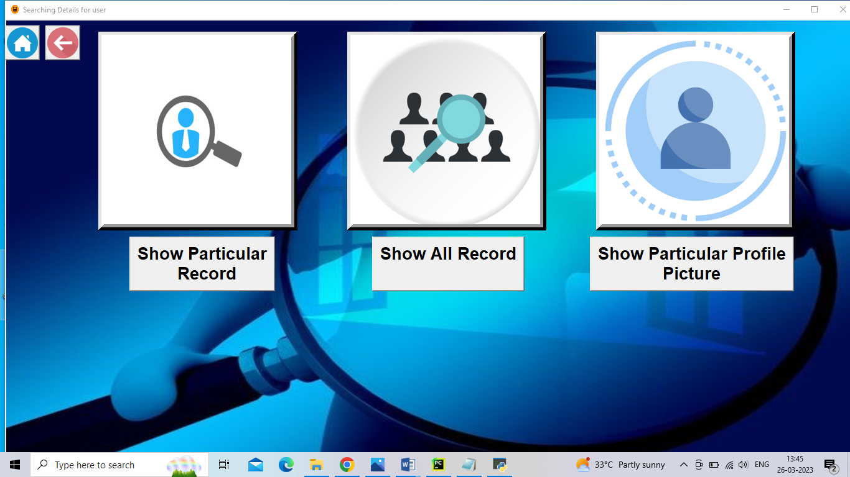

**Show Particular Record:**

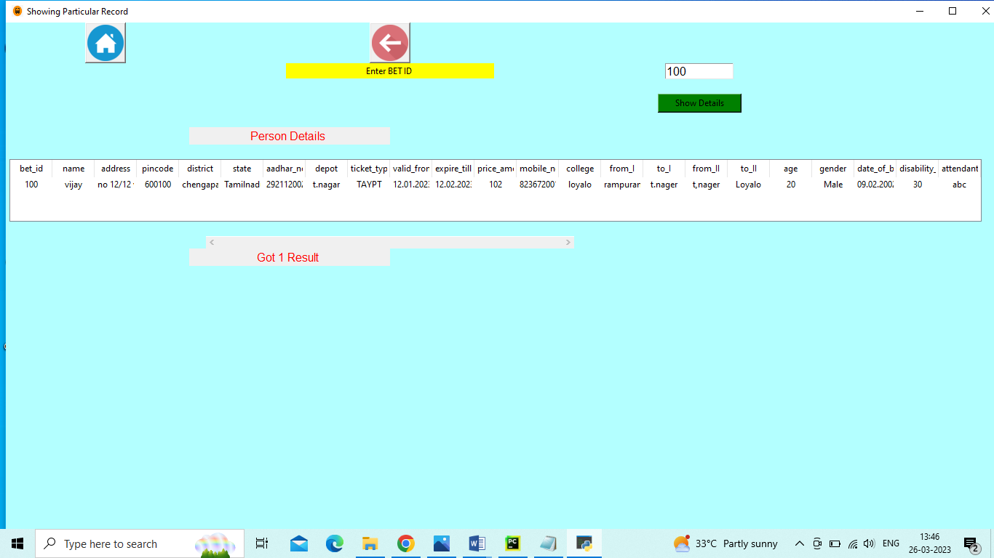

Chapter - 07

**Show All Record:**

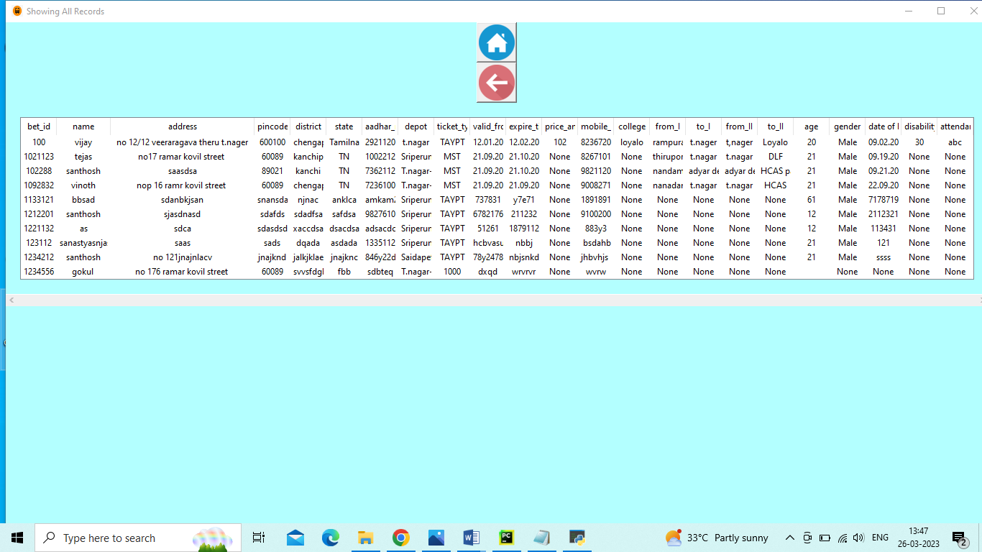

**Show Particular Profile Picture:**

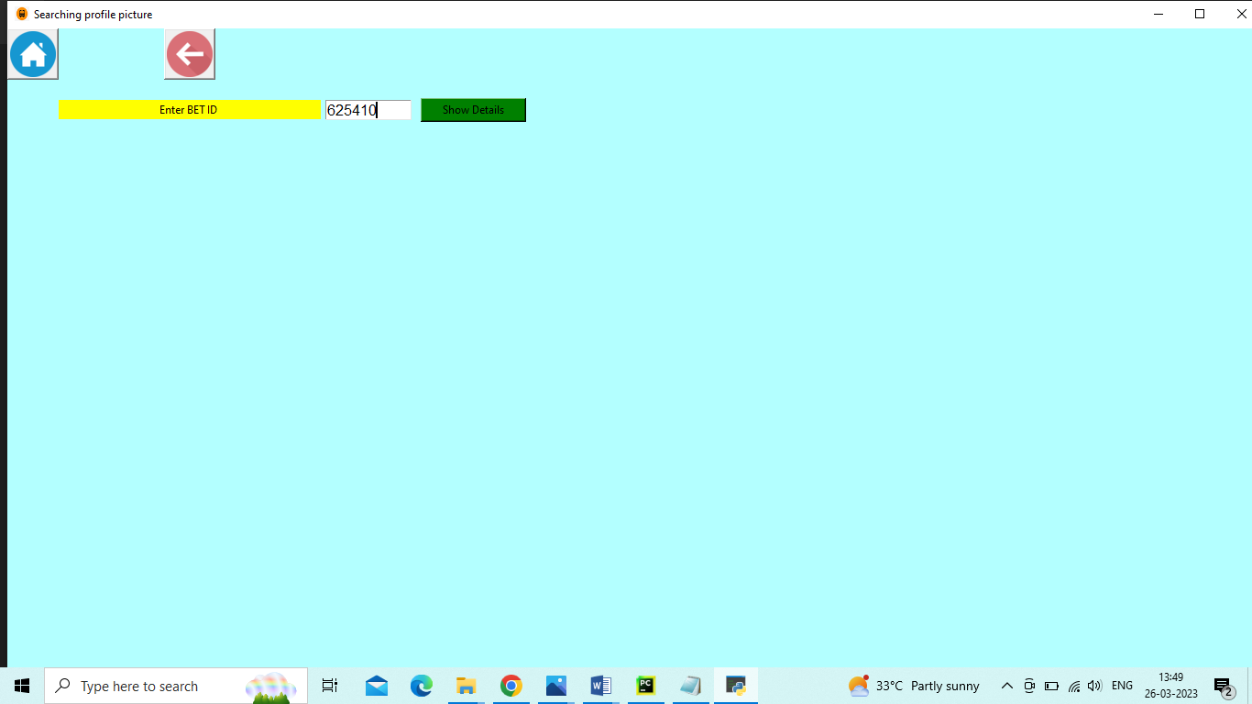

Chapter - 07

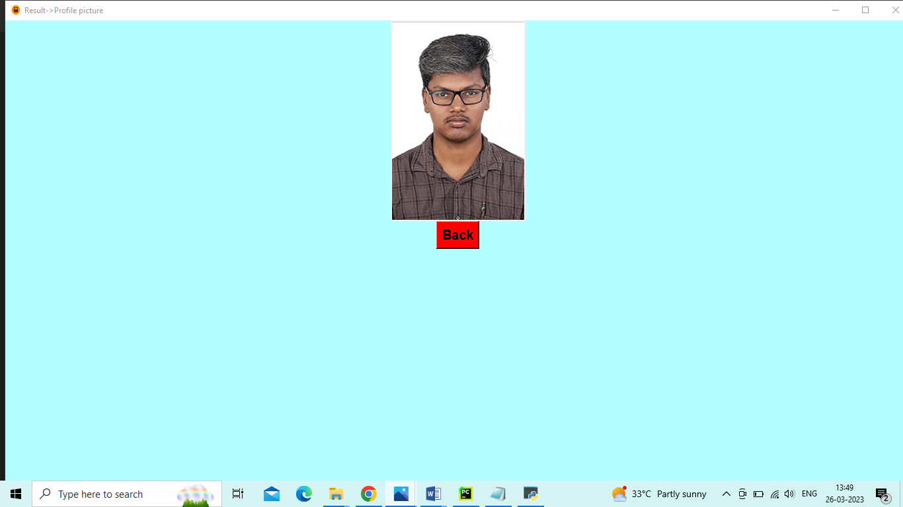

**Modify Bus E-Ticket Record:**

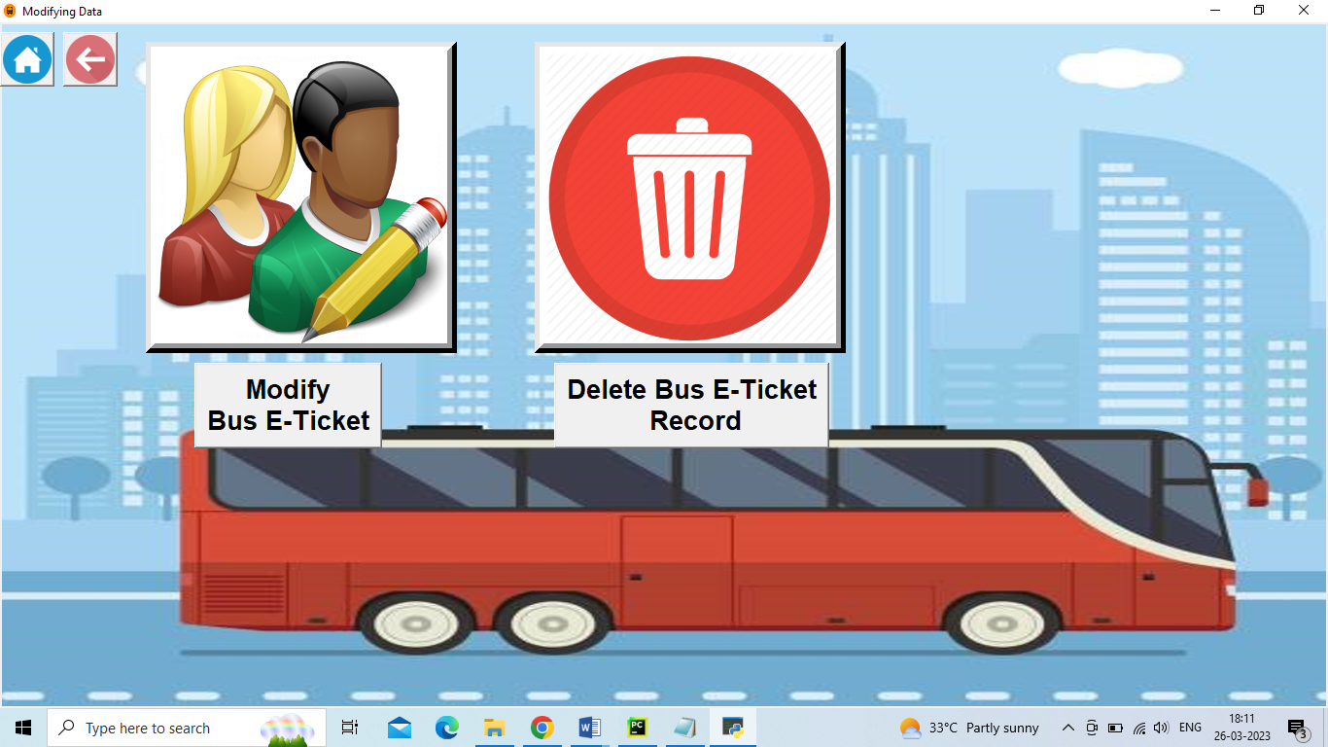

Chapter - 07

**Modify Bus E-Ticket:**

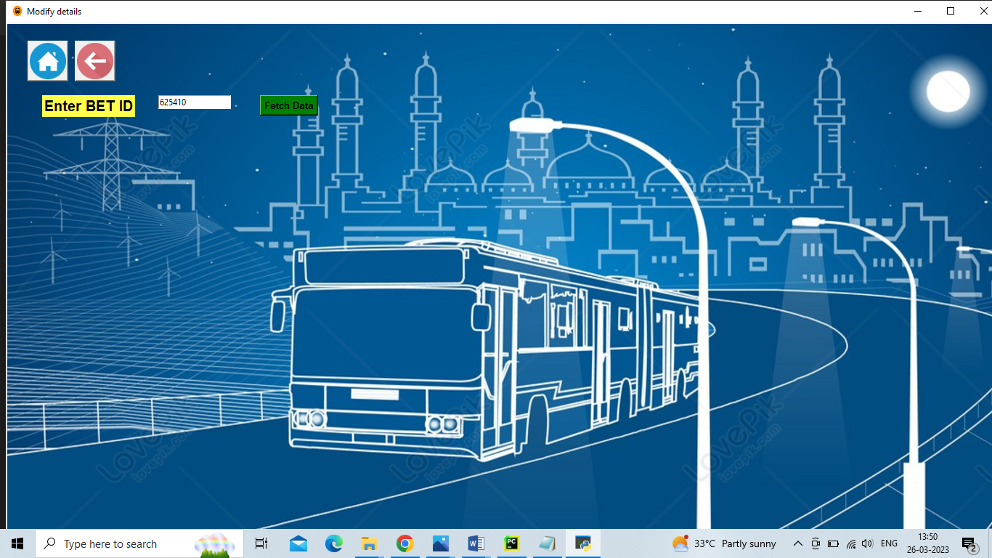

**Updating or Modifying the Details:**

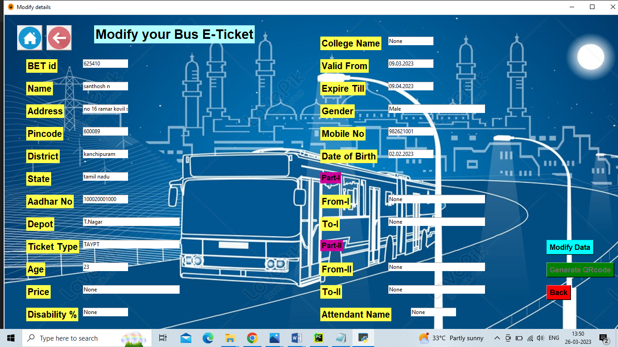

Chapter - 07

**Uploading the data in Database and Generating the QR-Code:**

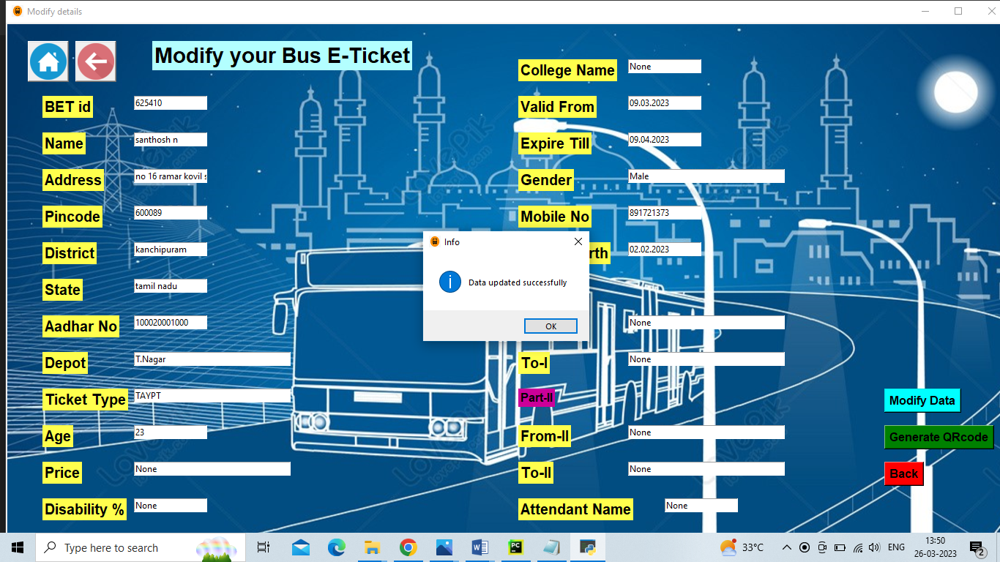

**Deleting the Bus E-Ticket Record:**

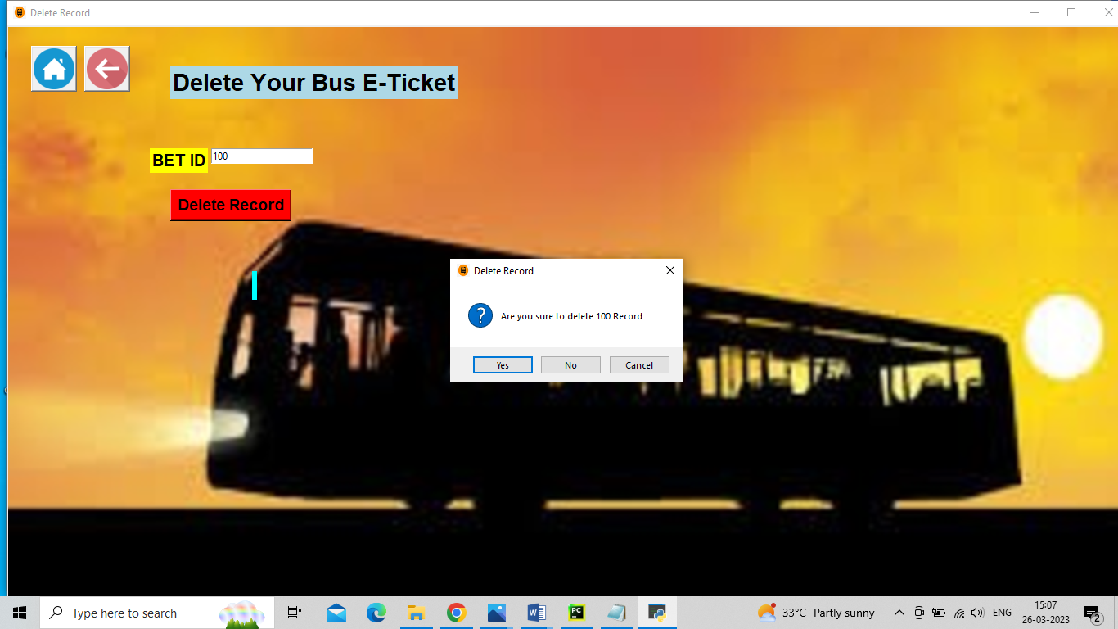

Chapter - 07

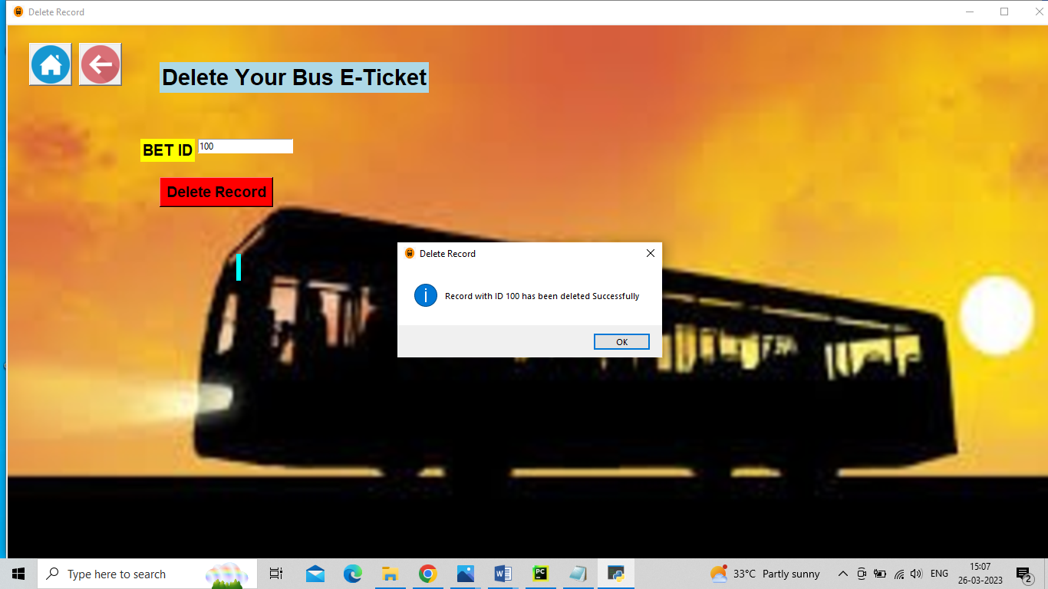

**Photos**

**Recent Event Photos:**

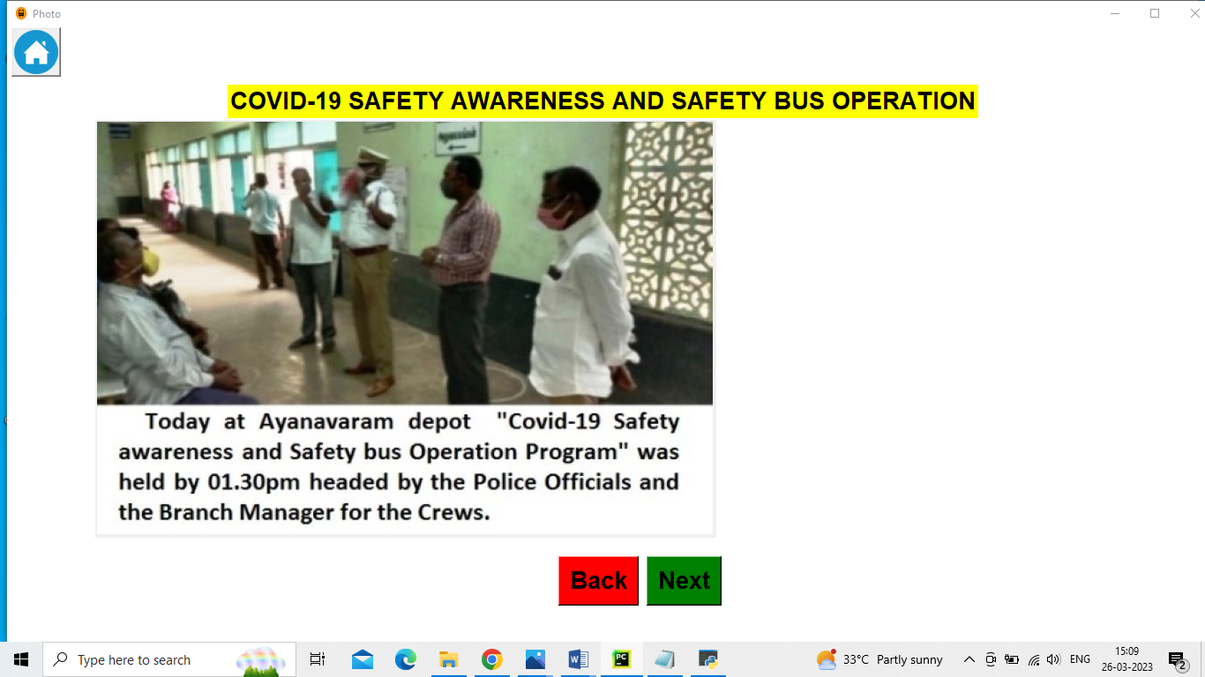

Chapter - 07

**About:**

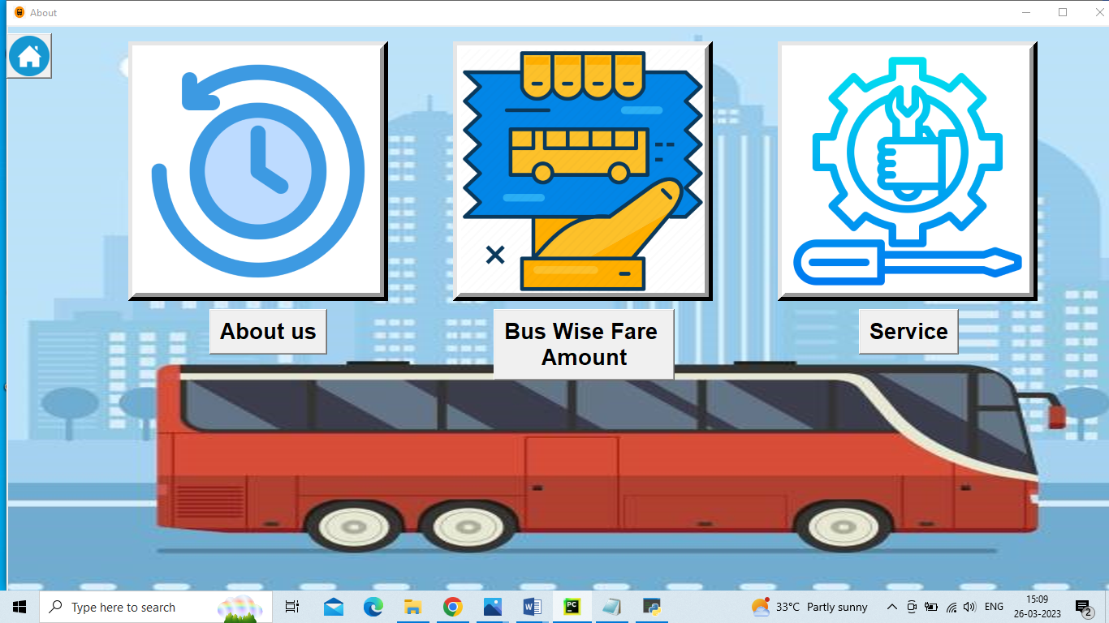

**About us:**

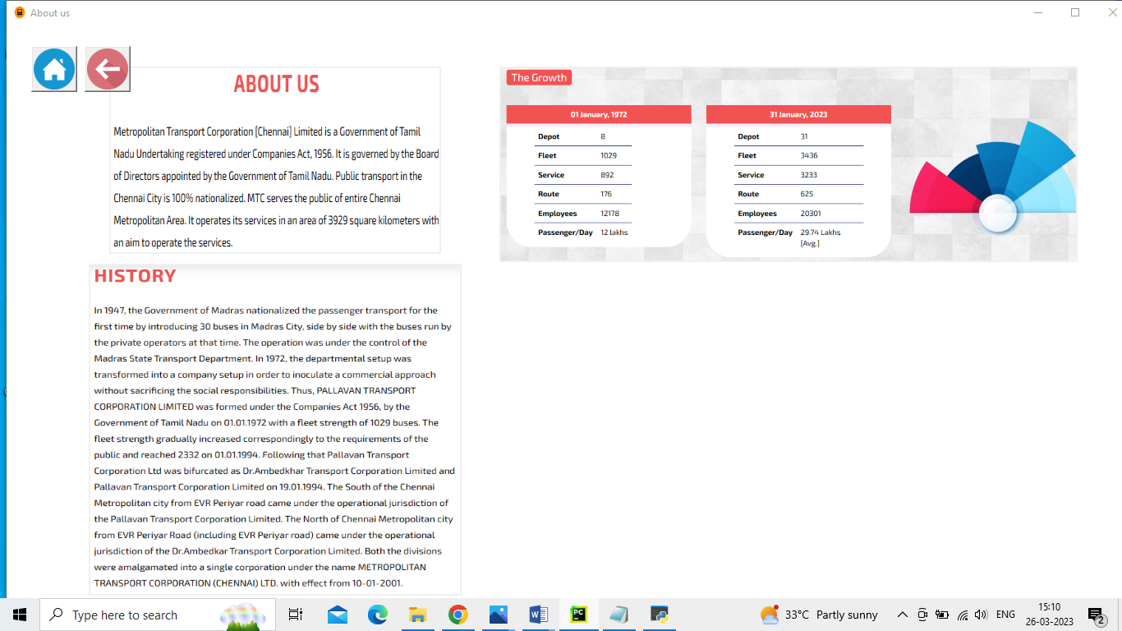

Chapter - 07

**Bus Wise Fare Amount:**

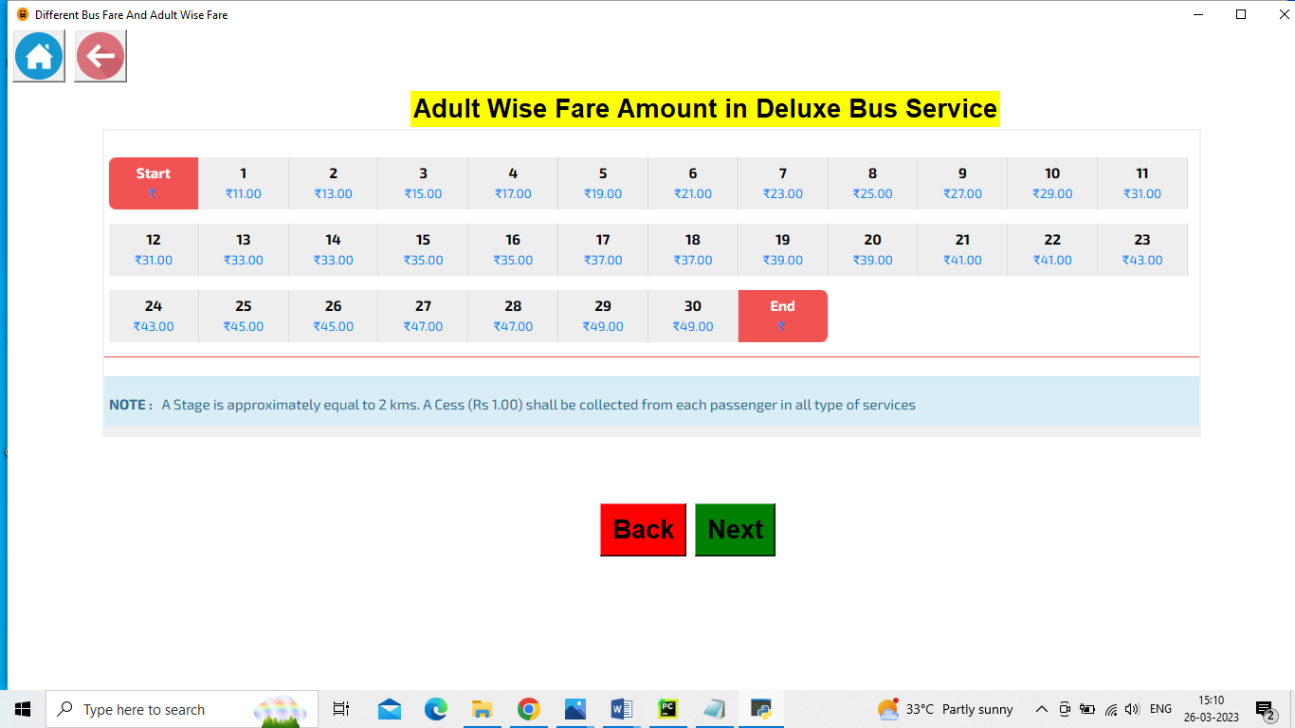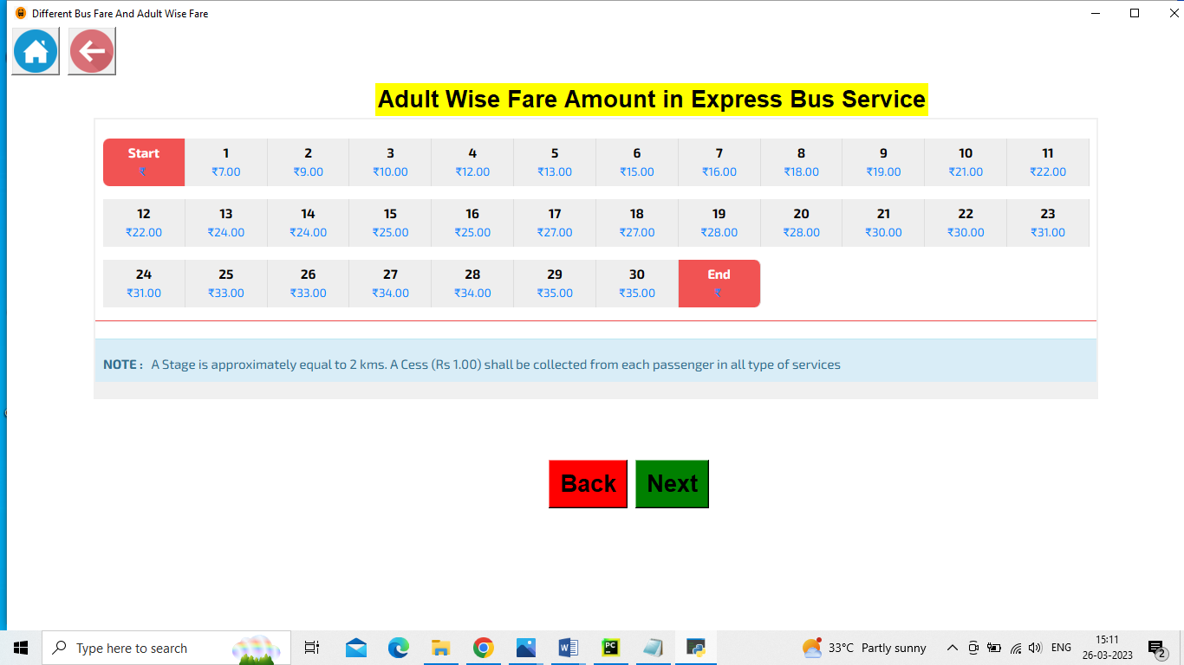

Chapter - 07



**Service:**

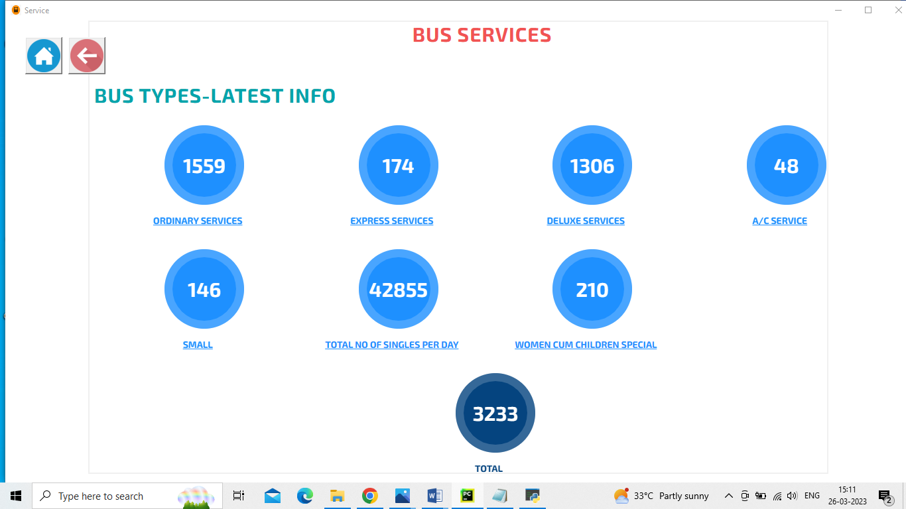

Chapter - 07

**Logout:**

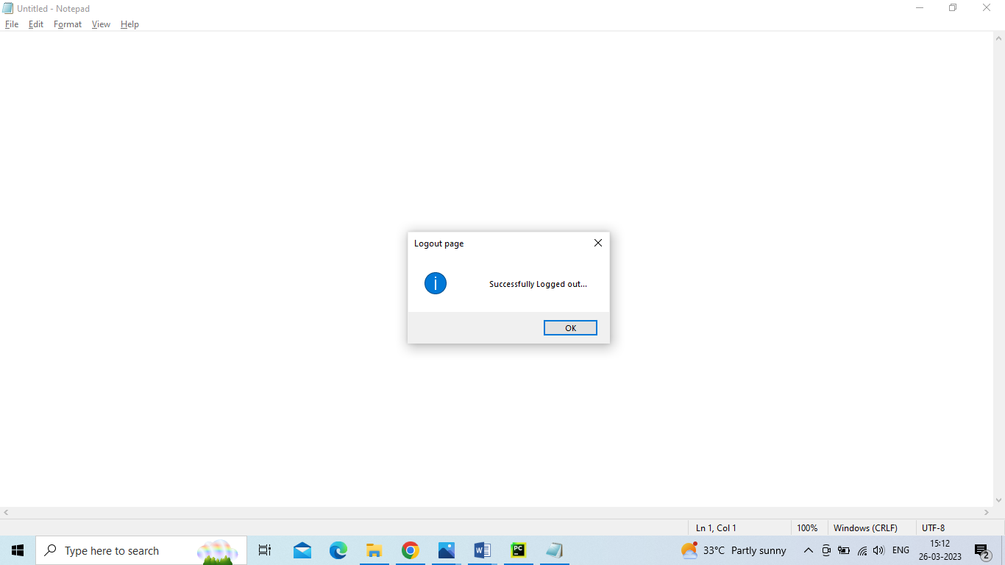

Chapter - 07

**7.3 Sample Reports**

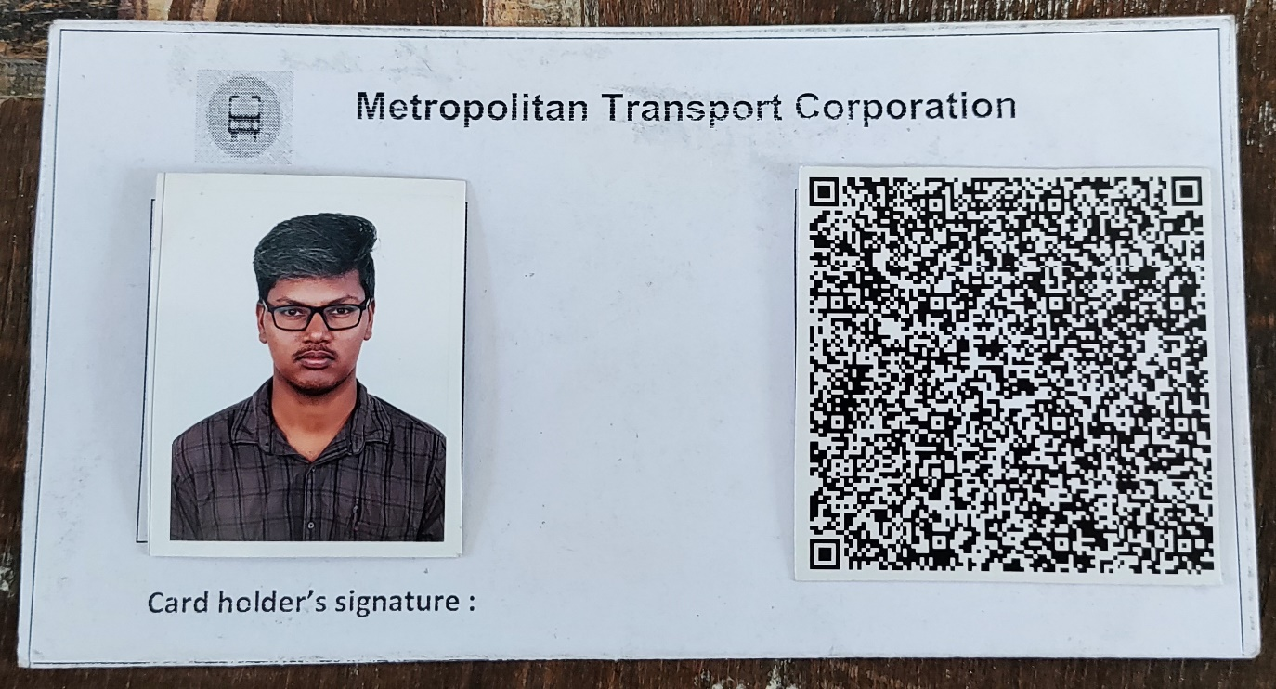

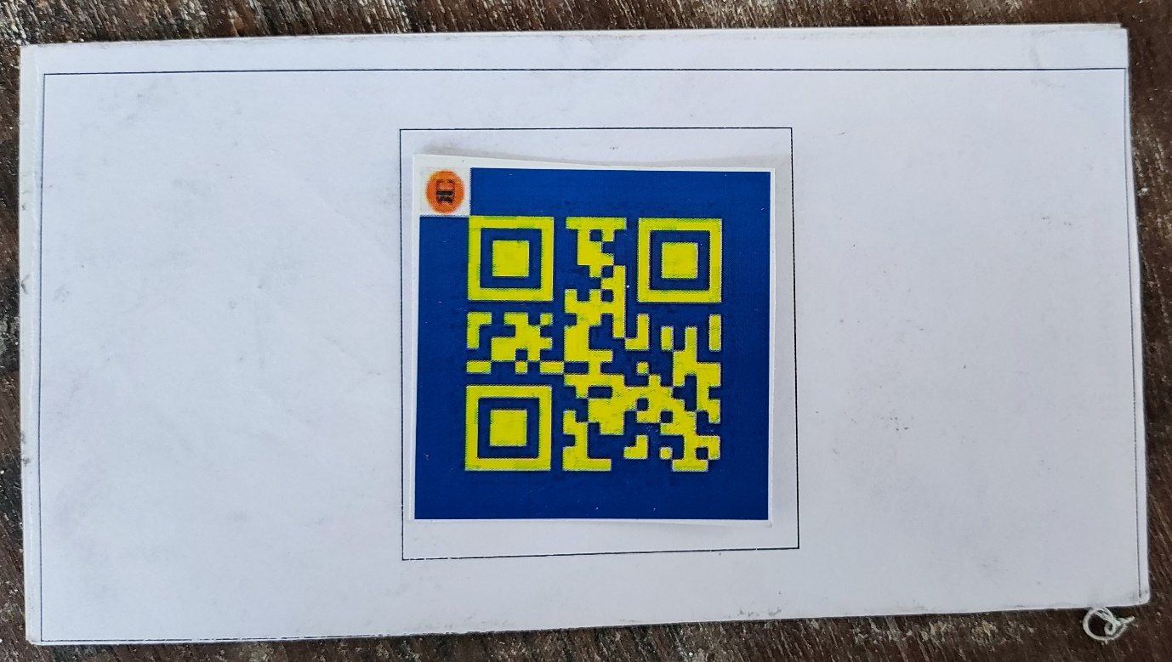

Chapter – 07

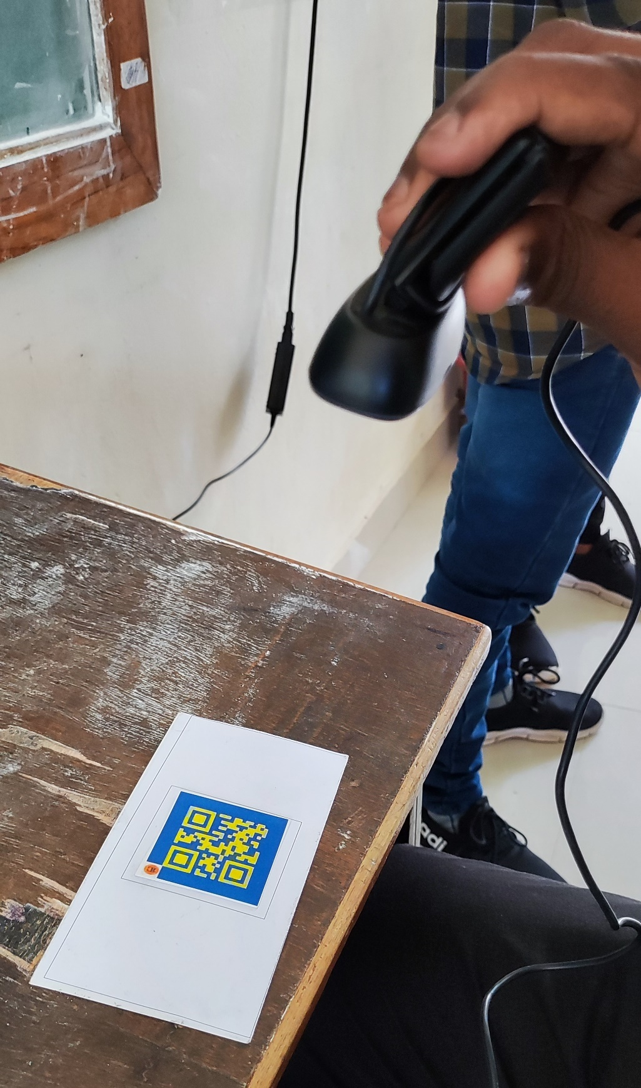

Chapter - 07

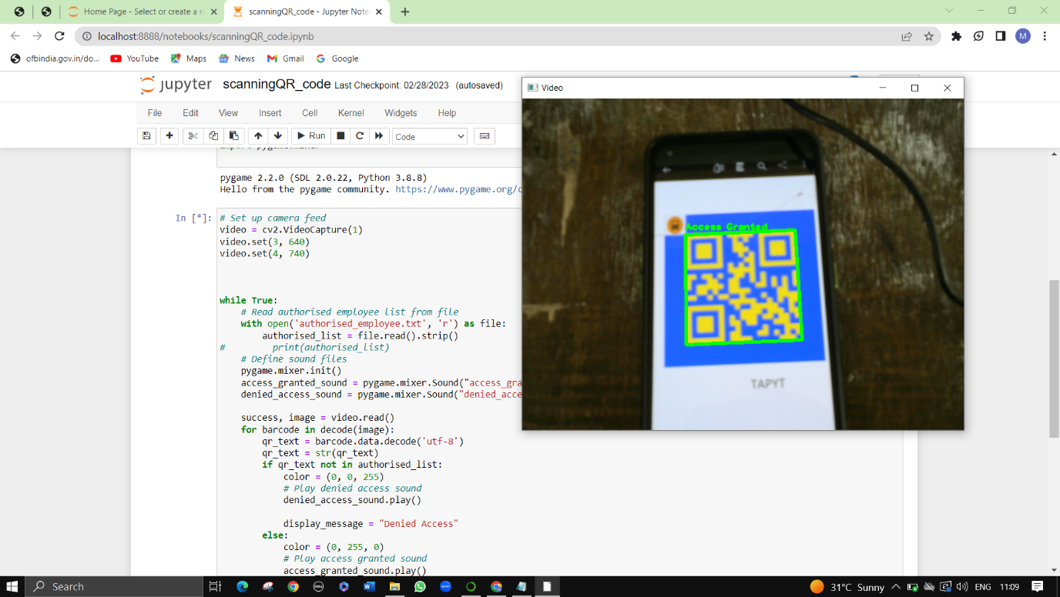

When the user properly paid and updated the pass it will display as Access granted or else it will display Access Denied

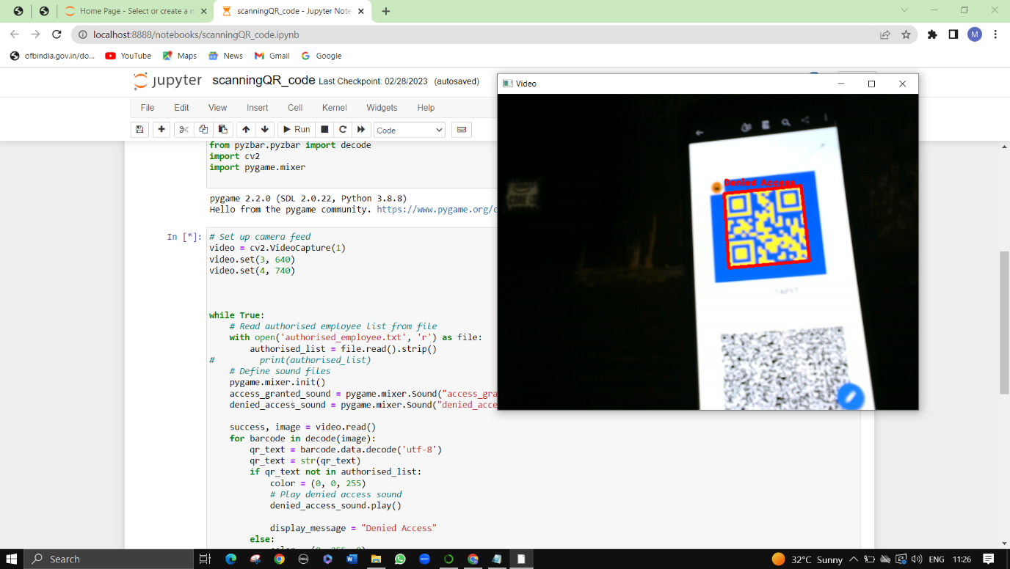

Chapter - 08

**8. CONCLUSION**

In this project I have developed a system which makes the Metropolitan transport Corporation (MTC) to sell the Pass and manage the data of the customer/user easily. It covers the functional areas such as Showing the details of the customer/user, Modifying/ Deleting the details of the user/customer, Can know the recently held event photos to the admin or staff. So, this can help in increasing the sales and Growth of the Metropolitan Transport Corporation (MTC) through the help of BUS E-TICKET MANAGEMENT instead of printing the Traditional paper based Tickets

And in this project the BUS E-TICKET DETECTION is used so that the man power is reduced because No need of BUS CONDUCTOR just the customers/user just scan the QR-Code and they can Travel Were the need to go.

Chapter - 09

**9. FUTURE ENCHANCEMENT**

In future the PAY & GET pass is enhanced based on the GPS location, where the user/customer travel from ONE BUS-STOP to ANOTHER BUS-STOP in between BUS-STOPS it will calculate the price amount and takes it from the User’s/customer’s Amount and update the Database for Next travel. So that man power is reduced and MTC can avoid loss and MTC can develop the bus infrastructure or deploy many buses in new routes and busy/crowd routes.so the people can enjoy their travel

Chapter - 10

**10.BIBLIOGRAPHY**

* https://docs.python.org
* <https://openai.com>
* <https://www.plus2net.com>
* <https://mtcbus.tn.gov.in>